Irene Data Analysis Progress

Mwaura Patrick

2/8/2021

## Summary of the data

View the summary of the data

## Number of camels from each of the Livestock Production System

With their Percentages and Bar Graph

H0: There is no association/relationship between community/ranch and the livestock production system H1: There is an association / relationship between community/ranch and livestock production system

Reject the null hypothesis

| Ranch vs Livestock production system With Percentages | | | |
| --- | --- | --- | --- |
| **Community** | **Extensive** | **Intensive** | **Total** |
| Ilmotiok | 100% (137) | 0% (0) | 45% (137) |
| Loisaba Ranch | 0% (0) | 33% (55) | 18% (55) |
| Mpala Ranch | 0% (0) | 48% (80) | 26% (80) |
| Suyian Ranch | 0% (0) | 19% (32) | 11% (32) |
| Total | 100% (137) | 100% (167) | 100% (304) |

##   
## Pearson's Chi-squared test  
##   
## data: .  
## X-squared = 304, df = 3, p-value < 2.2e-16

##   
## Fisher's Exact Test for Count Data  
##   
## data: comm  
## p-value < 2.2e-16  
## alternative hypothesis: two.sided

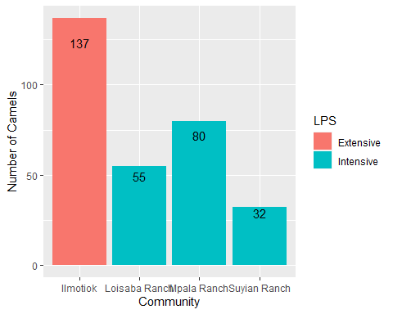

## Counts and Percentages of E.coli Isolated from all the camels

This table counts and percentages of E.coli isolates in Extensive/Intensive location/Livestock procuction system

H0: There is no association/relationship between micro organism and the livestock production system H1: There is an association / relationship between micro organism and livestock production system

Reject the null hypothesis

| E.coli recovered from each of the LPS | | | |
| --- | --- | --- | --- |
| **mo** | **Extensive** | **Intensive** | **Total** |
| Escherichia coli | 36% (49) | 44% (74) | 40% (123) |
| Others | 64% (88) | 56% (93) | 60% (181) |
| Total | 100% (137) | 100% (167) | 100% (304) |

##   
## Pearson's Chi-squared test with Yates' continuity correction  
##   
## data: .  
## X-squared = 1.9402, df = 1, p-value = 0.1636

##   
## Fisher's Exact Test for Count Data  
##   
## data: mo  
## p-value = 0.1587  
## alternative hypothesis: true odds ratio is not equal to 1  
## 95 percent confidence interval:  
## 0.4279657 1.1416908  
## sample estimates:  
## odds ratio   
## 0.700619

## Pie Chart

The above table can be visualised as a pie chart 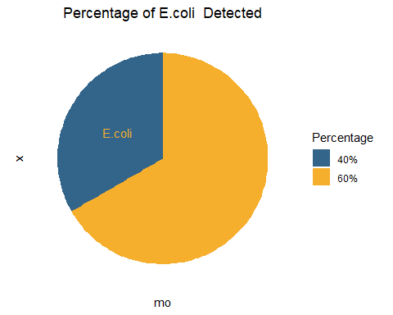

## Counts and percentages of the number of camels (female and male) from each livestock production system

H0: There is no association/relationship between gender and the livestock production system H1: There is an association / relationship between gender and livestock production system

Reject the Null hypothesis:There is a significant relationship between Gender and Livestock production system. Therefore, knowing the value of one may help to give vital information about the other .

| Camels(Female and Male) from each of the LPS | | | |
| --- | --- | --- | --- |
| **Gender** | **Extensive** | **Intensive** | **Total** |
| Female | 51% (110) | 49% (107) | 100% (217) |
| Male | 31% (27) | 69% (60) | 100% (87) |
| Total | 45% (137) | 55% (167) | 100% (304) |

##   
## Pearson's Chi-squared test with Yates' continuity correction  
##   
## data: .  
## X-squared = 8.9148, df = 1, p-value = 0.002829

##   
## Fisher's Exact Test for Count Data  
##   
## data: .  
## p-value = 0.002153  
## alternative hypothesis: true odds ratio is not equal to 1  
## 95 percent confidence interval:  
## 1.311810 4.031162  
## sample estimates:  
## odds ratio   
## 2.278384

## The count and percentages of Resistance/Intermediate/Susceptible E.coli to all the antibiotics

| Antibiotic Susceptibility Intermediate and Resistance | | | |
| --- | --- | --- | --- |
| **antibiotic** | **S** | **I** | **R** |
| Amoxicillin/clavulanic acid | 99% (122) | 1% (1) | 0% (0) |
| Ampicillin | 85% (104) | 6% (7) | 10% (12) |
| Cefaclor | 22% (27) | 50% (61) | 28% (35) |
| Cefepime | 75% (92) | 22% (27) | 3% (4) |
| Cefotaxime | 59% (73) | 24% (30) | 16% (20) |
| Ceftazidime | 67% (83) | 24% (30) | 8% (10) |
| Ceftriaxone | 89% (110) | 7% (9) | 3% (4) |
| Cefuroxime | 83% (102) | 13% (16) | 4% (5) |
| Chloramphenicol | 100% (123) | 0% (0) | 0% (0) |
| Ciprofloxacin | 62% (76) | 37% (45) | 2% (2) |
| Gentamicin | 90% (111) | 9% (11) | 1% (1) |
| Norfloxacin | 100% (123) | 0% (0) | 0% (0) |
| Streptomycin | 90% (111) | 7% (9) | 2% (3) |
| Tetracycline | 93% (115) | 2% (2) | 5% (6) |
| Trimethoprim/sulfamethoxazole | 96% (118) | 1% (1) | 3% (4) |

## Bug Drug Combination and grouping where possible

## NOTE: Using column 'mo' as input for `col_mo`.

| Antibiotics Combination | | |
| --- | --- | --- |
| **Group** | **Drug** | **Gram-negative** |
| Aminoglycosides | Gentamicin(GEN,J01GB03) | 0.8% (1/123) |
|  | Streptomycin(STR1,J01GA01) | 2.4% (3/123) |
| Amphenicols | Chloramphenicol(CHL,J01BA01) | 0.0% (0/123) |
| Beta-lactams/penicillins | Amoxicillin/clavulanic acid(AMC,J01CR02) | 0.0% (0/123) |
|  | Ampicillin(AMP,J01CA01) | 9.8% (12/123) |
| Cephalosporins (2nd gen.) | Cefaclor(CEC,J01DC04) | 28.5% (35/123) |
|  | Cefuroxime(CXM,J01DC02) | 4.1% (5/123) |
| Cephalosporins (3rd gen.) | Cefotaxime(CTX,J01DD01) | 16.3% (20/123) |
|  | Ceftazidime(CAZ,J01DD02) | 8.1% (10/123) |
|  | Ceftriaxone(CRO,J01DD04) | 3.3% (4/123) |
| Cephalosporins (4th gen.) | Cefepime(FEP,J01DE01) | 3.3% (4/123) |
| Quinolones | Ciprofloxacin(CIP,J01MA02) | 1.6% (2/123) |
|  | Norfloxacin(NOR,J01MA06) | 0.0% (0/123) |
| Tetracyclines | Tetracycline(TCY,J01AA07) | 4.9% (6/123) |
| Trimethoprims | Trimethoprim/sulfamethoxazole(SXT,J01EE01) | 3.3% (4/123) |

## Beta-lactams/Penicillins

Beta-lactam antibiotics are one of the most commonly prescribed drug classes with numerous clinical indications.

From a biochemical point of view, these drugs have a common feature, which is the 3-carbon and 1-nitrogen ring (beta-lactam ring) that is highly reactive. This class includes:

Penicillins,Cephalosporins,Carbapenems,Monobactams,Beta-lactamase inhibitors

column ‘AMC’ (amoxicillin/clavulanic acid), column ‘AMP’ (ampicillin), column ‘OXA’ (oxacillin), column ‘TEM’ (temocillin) NOTE: No antimicrobial agents of class cephalosporins (1st gen.) found (such as cefacetrile, cephapirin). Selecting cephalosporins (2nd gen.): column ‘CEC’ (cefaclor), column ‘CXM’ (cefuroxime) NOTE: No antimicrobial agents of class carbapenems found (such as doripenem, imipenem).

| Beta-lactams Antibiotic Susceptibility Intermediate and Resistance | | | |
| --- | --- | --- | --- |
| **antibiotic** | **S** | **I** | **R** |
| Ampicillin | 85% (104) | 6% (7) | 10% (12) |
| Cefaclor | 22% (27) | 50% (61) | 28% (35) |
| Cefepime | 75% (92) | 22% (27) | 3% (4) |
| Cefotaxime | 59% (73) | 24% (30) | 16% (20) |
| Ceftazidime | 67% (83) | 24% (30) | 8% (10) |
| Ceftriaxone | 89% (110) | 7% (9) | 3% (4) |
| Cefuroxime | 83% (102) | 13% (16) | 4% (5) |

## Resistance

## Scale for 'y' is already present. Adding another scale for 'y', which will  
## replace the existing scale.

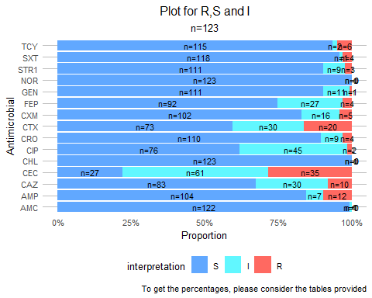

## Comparison table(extensive and Intensive)- percentage , resistance to all antibiotics

| Comparison table(Extensive and Intensive) Percentages , Resistance to all antibiotics | | | | | | | |
| --- | --- | --- | --- | --- | --- | --- | --- |
| AB_Group | AB | I.Ext | R.Ext | S.Ext | I.Int | R.Int | S.Int |
| Aminoglycosides | GEN | 9.26 | 1.85 | 88.9 | 7.32 | 0 | 92.7 |
| STR1 | 5.56 | 1.85 | 92.6 | 9.76 | 2.44 | 87.8 |
| Amphenicols | CHL | 0 | 0 | 100 | 0 | 0 | 100 |
| Beta-lactams/penicillins | AMC | 0 | 0 | 100 | 1.22 | 0 | 98.8 |
| AMP | 7.41 | 7.41 | 85.2 | 3.66 | 9.76 | 86.6 |
| Cephalosporins (2nd gen.) | CEC | 44.4 | 33.3 | 22.2 | 50 | 24.4 | 25.6 |
| CXM | 13 | 1.85 | 85.2 | 12.2 | 4.88 | 82.9 |
| Cephalosporins (3rd gen.) | CAZ | 31.5 | 9.26 | 59.3 | 17.1 | 6.1 | 76.8 |
| CRO | 5.56 | 1.85 | 92.6 | 7.32 | 3.66 | 89 |
| CTX | 24.1 | 16.7 | 59.3 | 20.7 | 15.8 | 63.4 |
| Cephalosporins (4th gen.) | FEP | 22.2 | 1.85 | 75.9 | 21.9 | 3.66 | 74.4 |
| Quinolones | CIP | 35.2 | 0 | 64.8 | 39 | 2.44 | 58.5 |
| NOR | 0 | 0 | 100 | 0 | 0 | 100 |
| Tetracyclines | TCY | 1.85 | 0 | 98.2 | 1.22 | 8.54 | 90.2 |
| Trimethoprims | SXT | 0 | 1.85 | 98.2 | 1.22 | 3.66 | 95.1 |

## Multidrug Resistance Organisms MDR

#### Please explain the two tables and what the difference mean to the study.

The main varaition is the minimal required percentage of the antimicrobial classes that must be available per isolate , rounded down . For example , at 50%, how many antibmicrobial classes must be available and hence the graphs i have presented are at 0% and 100% respectively , please guide on this and what percentage I should input.

#### Please also be aware i am following MDRO guidline as perthe publication by Magiorakos et al.

Negative (Resistant to atmost tow(2) antibiotic) Multi-drug-resistant (MDR) Extensively drug-resistant (XDR)  
Pandrug-resistant (PDR)

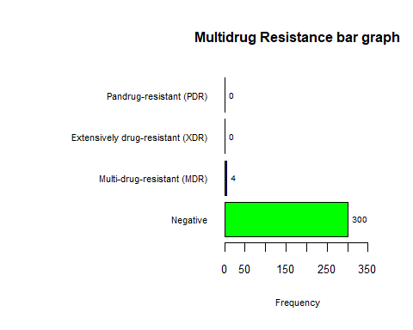

## . :   
## Frequency Percent  
## Negative 300 98.7  
## Multi-drug-resistant (MDR) 4 1.3  
## Extensively drug-resistant (XDR) 0 0.0  
## Pandrug-resistant (PDR) 0 0.0  
## Total 304 100.0

## Antibiotic Profiling

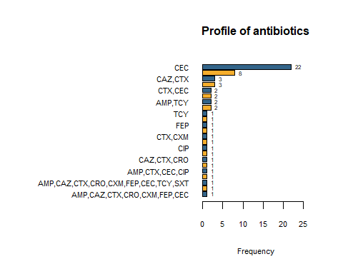

| Antibiotics Profiles with number of isolates Resistants | | |
| --- | --- | --- |
| **Antibiotic** | **Frequency** | **Percentage** |
| CEC | 22 | 37.3 |
| CTX | 8 | 13.6 |
| CAZ,CTX | 3 | 5.1 |
| AMP,CEC | 3 | 5.1 |
| CTX,CEC | 2 | 3.4 |
| CAZ | 2 | 3.4 |
| AMP,TCY | 2 | 3.4 |
| AMP | 2 | 3.4 |
| TCY | 1 | 1.7 |
| SPT | 1 | 1.7 |
| FEP | 1 | 1.7 |
| CXM | 1 | 1.7 |
| CTX,CXM | 1 | 1.7 |
| CTX,CEC,TCY,SPT,SXT | 1 | 1.7 |
| CIP | 1 | 1.7 |
| CEC,GEN | 1 | 1.7 |
| CAZ,CTX,CRO | 1 | 1.7 |
| CAZ,CEC | 1 | 1.7 |
| AMP,CTX,CEC,CIP | 1 | 1.7 |
| AMP,CEC,TCY,SPT,SXT | 1 | 1.7 |
| AMP,CAZ,CTX,CRO,CXM,FEP,CEC,TCY,SXT | 1 | 1.7 |
| AMP,CAZ,CTX,CRO,CXM,FEP,CEC,SXT | 1 | 1.7 |
| AMP,CAZ,CTX,CRO,CXM,FEP,CEC | 1 | 1.7 |
| Totals | 59 | 100.0 |

### GENE ProfileS

| TEM Genes antibiotics Resistant profile | | |
| --- | --- | --- |
| **TEM** | **antibiotics** | **Antibiotics_Count** |
| TEM 104 | AMP, TCY | 2 |
| TEM 116 | AMP, CAZ, CTX, CRO, CXM, FEP, CEC, TCY | 8 |
| TEM 1A | AMP, CAZ, CTX, CRO, CXM, FEP, CEC | 7 |
| TEM 214 | AMP, CAZ, CTX, CRO, CXM, FEP, CEC, TCY, SXT | 9 |
| TEM 243 | AMP, CTX, CEC, TCY, STR1, CIP, SXT | 7 |
| CTX-M Genes antibiotics Resistant profile | | |
| **CTX_M** | **antibiotics** | **Antibiotics_Count** |
| CTX-M 15 | AMP, CAZ, CTX, CRO, CXM, FEP, CEC, CIP | 8 |
| CTX-M 238 | AMP, CAZ, CTX, CRO, CXM, FEP, CEC, TCY, SXT | 9 |
| CTX-M 27 | AMP, CAZ, CTX, CRO, CXM, FEP, CEC, SXT | 8 |

### GENES WITH RESPECT TO LPS

H0: There is no association/relationship between gene and the livestock production system H1: There is an association / relationship between gene and livestock production system

| TEM GENE | | |
| --- | --- | --- |
| **TEM** | **Extensive** | **Intensive** |
| TEM 104 | 0% (0) | 7% (1) |
| TEM 116 | 75% (6) | 57% (8) |
| TEM 1A | 12% (1) | 7% (1) |
| TEM 214 | 0% (0) | 7% (1) |
| TEM 243 | 12% (1) | 21% (3) |

##   
## Fisher's Exact Test for Count Data  
##   
## data: .  
## p-value = 1  
## alternative hypothesis: two.sided

| CTX-M GENE | | |
| --- | --- | --- |
| **CTX_M** | **Extensive** | **Intensive** |
| CTX-M 15 | 0% (0) | 67% (2) |
| CTX-M 238 | 0% (0) | 33% (1) |
| CTX-M 27 | 100% (1) | 0% (0) |

##   
## Fisher's Exact Test for Count Data  
##   
## data: .  
## p-value = 0.5  
## alternative hypothesis: two.sided

### Beta-lactams to all genes and counts pecentages

| Beta-Lactams TEM GENE Resistant profile | | |
| --- | --- | --- |
| **TEM** | **variable** | **Antibiotics_Count** |
| TEM 104 | AMP | 1 |
| TEM 116 | AMP, CEC, FEP, CXM, CRO, CTX, CAZ | 7 |
| TEM 1A | AMP, CEC, FEP, CXM, CRO, CTX, CAZ | 7 |
| TEM 214 | AMP, CEC, FEP, CXM, CRO, CTX, CAZ | 7 |
| TEM 243 | AMP, CEC, CTX | 3 |
| Beta-Lactams CTX-M GENE Resistant profile | | |
| **CTX_M** | **variable** | **Antibiotics_Count** |
| CTX-M 15 | AMP, CEC, FEP, CXM, CRO, CTX, CAZ | 7 |
| CTX-M 238 | AMP, CEC, FEP, CXM, CRO, CTX, CAZ | 7 |
| CTX-M 27 | AMP, CEC, FEP, CXM, CRO, CTX, CAZ | 7 |